**Spark Installation**

* If we do MapReduce in Horton SandBox , there is no need for a separate spark installation. It is already installed in it.
* We can test the existence of spark by trying to run some of its commands like :

> spark-shell

> spark-submit

* All the procedures we followed for hadoop MapReduce will be the same we just use different spark commands.
* Some how if we can’t find it installed, the steps are:-

1. Download tar file from this link (<http://public-repo-1.hortonworks.com/HDP-LABS/Projects/spark/1.2.0/spark-1.2.0.2.2.0.0-82-bin-2.6.0.2.2.0.0-2041.tgz>)
2. Extract it

> tar xvf spark-1.1.0.tgz

3. Set spark hadoop version in env variables ; > SPARK_HADOOP_VERSION=2.6.0

**Eclipse Setup**

* First we create a java project
* Right click on the project > configure > convert to maven
* Inside the POM file that will be created we append the following lines of code

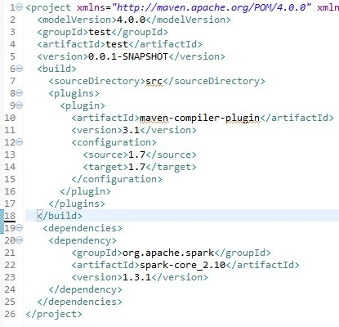

* Now Create Java classes and put your code.
* Create a jar file and run it in spark with the following command
* Spark-submit fileSpark.jar /input /output